**EXPERIMENT 03**

**AIM: To Implement Gas leakage detector circuit using MQ-02/03 Gas sensor with Arduino**

**APPARATUS**:

1. Arduino UNO
2. Breadboard
3. MQ2/MQ3
4. Connecting wires.
5. USB Cable

# **THEORY:**

Gas Sensor (MQ2) module is useful for gas leakage detection (home and industry). It is suitable for detecting H2, LPG, CH4, CO, Alcohol, Smoke or Propane. Due to its high sensitivity and fast response time, measurement can be taken as soon as possible. The sensitivity of the sensor can be adjusted by potentiometer.

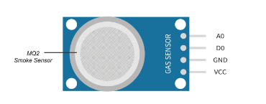

**Figure 3.1: MQ2 Sensor pinout**

The VCC is the power supply pin of the Gas Detection Sensor that can be connected to 5V of the supply. GND is the ground pin of the board and it should be connected to the ground pin of the Arduino. D0 is the Digital output pin of the board, output low indicates gas or smoke is not present in the atmosphere and output high indicates gas or smoke is present in the atmosphere. A) is the Analog output pin of the board that will give us an analog signal which will vary between vcc and ground based on the gas level detected.

he MQ-2 sensor is used to detect hazardous or flammable gas or smoke and hence this sensor is popular among beginners. Also these are low cost, easy to use sensors featuring a wide sensing range that can be trimmed down to adjust the sensitivity. The parts markings of the MQ-2 Gas Sensor is given below-

MQ-2 Gas Sensor Module

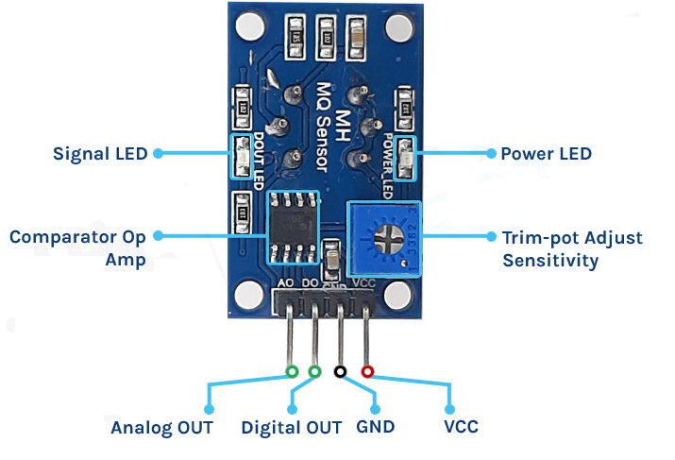

Figure 3.2 Gas sensor module parts

Like all the other basic sensor modules, this MQ-2 Gas and smoke sensor module has four pins, two of which are for VCC and Gnd and the other two can simultaneously output analog and digital data. To power the circuit we are using the 5V pin of the arduino because the operating voltage range of this module is 5V with ±0.1% tolerance. As you can see in the image above the module has two onboard LEDs. The power LED turns on when power is applied to the board and the D0 LED turns on when the trigger value set by the potentiometer is reached. This board also has a comparator OP-Amp onboard that is responsible for converting the incoming analog signal from the gas sensor to a digital signal. We also have a sensitivity adjustment Trim-pot, with that we can adjust the sensitivity of the device. Finally we have some resistor capacitors for decoupling and filtering.

**PROCEDURE:**

1. **Connecting MQ2 to Arduino**
2. Connect the leftmost pin of MQ2 to the A0 of Arduino using breadboard.
3. Similarly, connect the third pin GND to GND pin of Arduino using Bread Board.
4. Lastly connect the right most pin of MQ2 to the VCC. (Table 5.2)

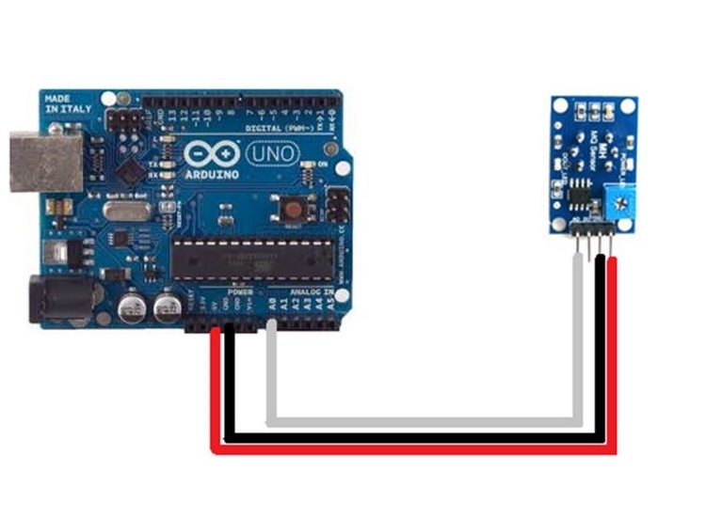

**Figure 3.3 : Connecting Standalone DHT11**

**Table 3.1: Connection of DHT11 to Arduino**

|  |  |  |
| --- | --- | --- |
| **S.no** | **Arduino** | **Breakout MQ2** |
| **1.** | GND | GND |
| **2.** | 5V | Vcc |
| **3.** | A0 | A0 |

**Figure 5.6: Program for taking humidity and temperature readings**

1. Connect the Arduino board to the laptop/computer using USB (Figure 5.7).
2. Execute the program on the editor.
3. Place a moist cotton or paper towel near the sensor and note down the readings.
4. The humidity and temperature readings are displayed at one second intervals (Figure 5.8 ).

#define MQ2pin (0)

float sensorValue; //variable to store sensor value

void setup()

{

Serial.begin(9600); // sets the serial port to 9600

Serial.println("Gas sensor warming up!");

delay(20000); // allow the MQ-2 to warm up

}

void loop()

{

sensorValue = analogRead(MQ2pin); // read analog input pin 0

Serial.print("Sensor Value: ");

Serial.print(sensorValue);

if(sensorValue > 200)

{

Serial.print(" | Smoke detected!");

}

Serial.println("");

delay(2000); // wait 2s for next reading

}

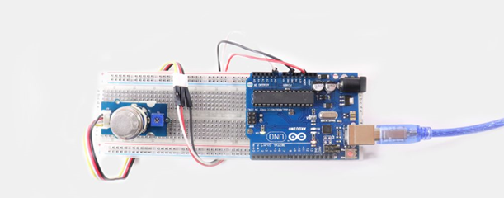

**Figure 3.4 Interfacing**

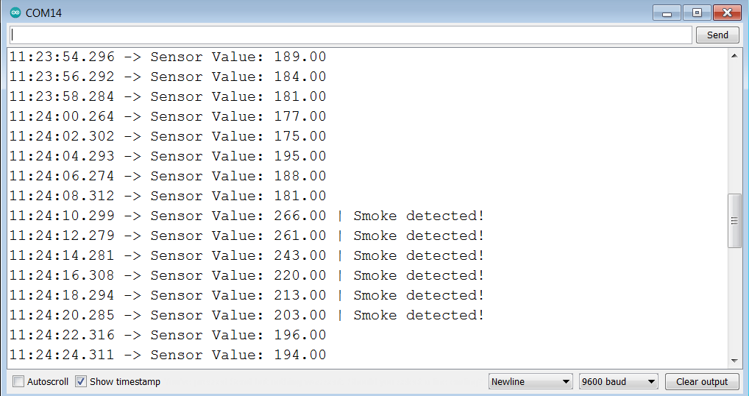

**Figure 3.5: Gas detection as output**

**OBSERVATIONS:**

|  |  |  |
| --- | --- | --- |
| **S.no.** | **Temperature (°C)** | **Humidity (RH)** |
|  |  |  |
|  |  |  |
|  |  |  |
|  |  |  |

**Table 5.3: Observation Table (Temperature and Humidity)**

# **PRECAUTIONS:**

1. The connections should be neat and tight.

2. Do not switch ON the power supply without checking and verifying the connections.

3. It should be ensured that the applied voltage do not exceed the ratings of module.

4. Read all instructions carefully before starting the experiment.

# **RESULTS:**

The basic working of the sensor has been studied and values of gas has been observed.